# Computer vision

## Sheet 01

### Parsa Eissazadeh ([s68peiss@uni-bonn.de](mailto:s68peiss@uni-bonn.de), 50234732)

### Pranav Yadav (s52pyada@uni-bonn.de 50327698)

## Q3

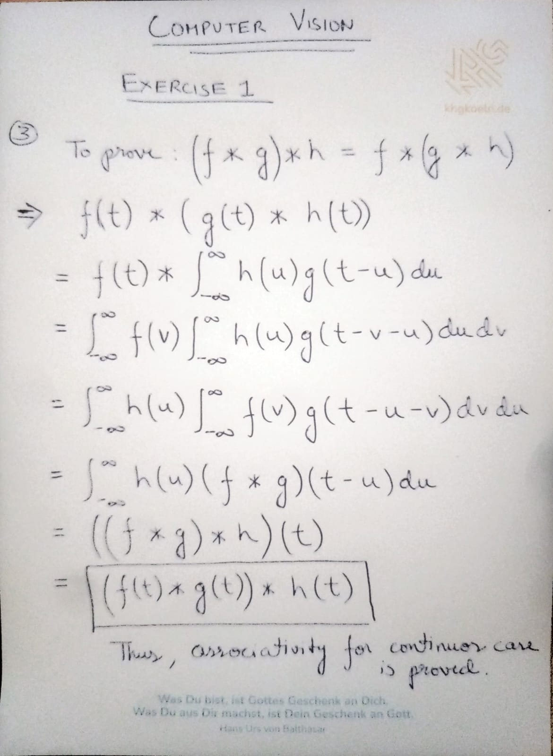

## Q6

